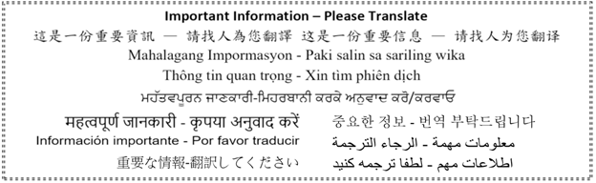

August 28, 2020
Dear Harbour View Parents/Guardians,
As you know, our school is getting ready to welcome students back to school in a safe and controlled manner. The Ministry of Education announced that BC schools will open in Stage 2 where students are encouraged to attend daily as schools will not be able to provide the remote learning options that we did in June. The first day of school for students is Thursday, September 10th. You can read more here: https://www2.gov.bc.ca/assets/gov/education/administration/kindergarten-to-grade-12/safe-caring-orderly/k-12-education-restart-plan.pdf. On Tuesday, September 8th and Wednesday, September 9th staff will be reviewing and implementing safety procedures within the school.
The Ministry also has a site with information for parents: https://www2.gov.bc.ca/gov/content/education-training/k-12/covid-19-return-to-school
We have worked under the guidance of public health authorities and the Ministry of Education to develop a plan so that students and staff can learn and work together safely and we are ready to welcome your child back to school. We will strive to keep learning as the focus, but school will look different as health and safety are critical factors in our planning. Below is a brief summary of some of the actions taken to safely restart school this September.
Health and Safety
- Daily health screening check for students (by parents) and staff before arriving at school.
- Students who are ill (cold, flu or showing Covid-19 symptoms) must stay home. If a child becomes ill during the school day, they will be isolated from their Learning Group/class and the parents will be contacted to come and pick your child up as soon as possible.
- Families arriving from outside of Canada must self-isolate for 14 days before entering school.
- There will be enhanced cleaning protocols especially focused on high touch points (doorknobs, faucets, etc.)
- Teachers will be encouraged to take their classes outside more frequently.
- Assigned drop off/pick up zones will be implemented to ensure physical distancing between Learning Groups/classes
- A staggered recess and lunch schedule will be adopted to promote physical distancing between Learning Groups/classes
- There will be no large gatherings (assemblies, special events, open house) at this time.
- Elementary students are welcome to wear a mask, but it is not mandatory at this time.
- No sharing of food or drink.
- There will be limited access to the building by parents and visitors. Parents and visitors must make an appointment in advance to meet with staff. All visitors must sign in at the office, acknowledge they have read and adhered to the health screening checklist, and provide contact information for the purpose of contact tracing. Virtual meetings will be encouraged for staff and parents.
- We also ask parents to also practice physical distancing (staying apart 2m) whenever on school grounds and wear a mask whenever physical distancing is not possible. This is for your safety and good modeling for our students.

Learning Groups
- A Learning Group is defined as a group of students and staff who remain together for an extended period of time and who interact primarily with each other.
  - In the Coquitlam School District, the Learning Group will include your child’s classmates and any staff assigned to work with the students on a regular basis, like your child’s teacher.
  - Within the learning group, while there will be less opportunities to physically distance, physical contact will be discouraged.
  - The learning group will stay together. Students will learn, eat and play together at recess and lunch.
  - Class size limits have not changed, therefore a kindergarten class will have no more than 22 students along with the staff who work regularly with the classroom; a primary class with no more than 24; and an intermediate class with no more than 30 students in the group.
  - The Ministry of Education has stated that Learning Groups cannot exceed 60 people at elementary school. Therefore, our Learning Group sizes are well under the provincial limits outlined in Stage 2. In most cases our Learning Groups will be kept well below 60.
- Morning, recess, lunch and afterschool schedules and routines will be adjusted to keep Learning Groups apart as much as possible.
- If children interact with students or staff from other learning groups, they will be expected to practice physical distancing wherever possible and not engage in physical contact. In some cases, specialist teachers who work with children from different learning groups (ie. Learning assistance or English as a Second Language) will wear a mask if physical distancing is challenging.
- Parents and students will learn who their child’s teacher and Learning Groups/class is before school begins on Monday, September 14th. We expect Learning Groups to be finalized and students attending full days beginning September 14th.
Educational Programming
- Our school will be focused on in-class instruction during stage 2.
- Students will spend most of their educational time in their classroom, as there will be reduced movement of students between learning spaces.
- Student well-being will be guiding educators in planning and supporting the successful return of students to school.
- Students with disabilities/diverse abilities will continue to be supported by the goals outlined in their IEP.
- Regular health and safety practices (frequent hand washing) will take up some instructional time.
- There will be an adjusted Welcome to Kindergarten schedule. Further information will be communicated soon.
- Students will continue to receive report cards.
- Parents of children who are medically diagnosed as immunocompromised by a physician should contact me by Tuesday, September 1st. The following links are provided for your reference:
http://www.bccdc.ca/Health-Info-Site/Documents/COVID-19-IS-Children-FAQ-BCCH.pdf
http://www.bccdc.ca/Health-Professionals-Site/Documents/COVID19-easing-social-distrancing-IS-children.pdf
Start & End Times
* Please note school will begin at 9:00 AM and students will be dismissed at 2:38 PM.
The adjustment to our dismissal time was made to accommodate increased distancing for our staggered outdoor break times while continuing to have the provincial number of daily & weekly instructional minutes for students.
2020/2021 Harbour View revised School Schedule
Cohort A | Cohort B
9:00 - 9:55  [55]  Blk 1 | 9:00 - 9:55  [55]  Blk 1
9:55 – 10:15  [20]  Blk 2a | 9:55 – 10:30  [35]  Blk 2a
10:15-10:30
10:30 - 11:05  [35]  Blk 2b | 10:30-10:45
10:45 – 11:05
[20]
Blk 2b
11:05 - 11:45  [40]  Blk 3a | 11:05 – 11:20  [15]  Flex blk
 | 11:20 – 12:15
11:45 - 12:00  [15]  Blk 3b  Instructional Eating time | [55]
 | Blk 3
12:00-12:30
Lunch A playtime outside
12:15 – 12:30
[15]
 | Instructional Eating time
12:30 - 1:25  [55]  Blk 4 | 12:30-1:00  Lunch B playtime outside
1:00-1:55

[55]
1:25 - 2:20  [55]  Blk 5 | Blk 4
2:20 – 2:38  [18] | 1:55 – 2:38  [43]

Gathering Locations
All learning groups will have a designated gathering location around the school where students will meet for pick-up by their teacher in the morning and drop-off at the end of the day. This will also act as their recess and lunch drop-off and pick-up locations. This will allow for controlled movement during entry and exit as well as through the halls. Parents and adults are asked to remain physically distanced from others during drop off and pick up times and to exit the grounds in a timely manner once their students have been picked up for class and at the end of the day. See the detailed map below.
Learning Group Physically distant Drop-off / Pick-up designated areas

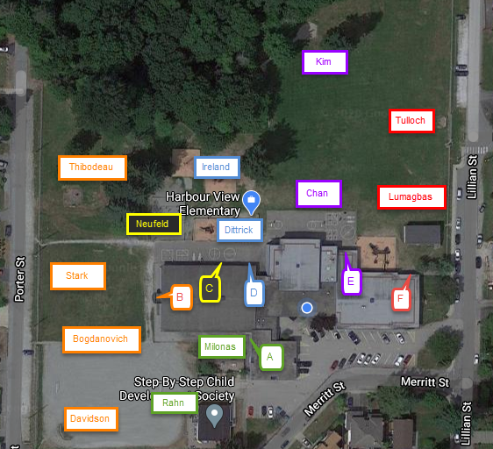

Teacher | Entrance/Exit | Drop-off/Pick-up zone
Thibodeau | Porter Porch | Porter baseball diamond
Lumagbas | Lillian door | Lillian baseball diamond
Rahn | Library Garden door | Gravel soccer goalpost
Kim | Rainbow undercover door | Sandpit
Neufeld | Classroom door | Pea gravel slide/swings play area
Tulloch | Lillian door | Grass soccer goalpost
Stark | Porter Porch | Porter Grass field
Chan | Rainbow undercover door | Grass adjacent blacktop
Ireland | Blacktop undercover door | Spiderweb/playground play area
Dittrick | Blacktop undercover door | Logs/playground play area
Milonas | Library Garden door | Garden/undercover area
Davidson | Porter Porch | Porter baseball diamond
Bogdanovich | Porter Porch | Porter gravel field
If you are dropping off / picking up by vehicle, please refrain from Merit Street or the Staff Parking lot due to traffic congestions. Please select either the Lillian drive and drop (no parking) or use the limited parking on Lillian below Bartlett OR park on Porter Street, whichever is closest to your child’s Drop off / Pick up zone identified on the map above.
*Please note, we encourage you to drop your children off at the vehicle no earlier than 8:50 am and not to congregate on the school grounds to maximize physical distancing.
Recess and Lunch
Students will eat their lunch in their classrooms under the supervision of their teacher and proper eating and hygiene habits will be reinforced. Harbour View will have staggered recess and lunch outside play times where half the learning groups (either in Cohort A or Cohort B) will be outside during their assigned time. Learning Groups will have assigned play zones they will need to remain in during their recess and lunch break time (back gravel & swing area, playground, field, blacktop area, etc.). Play areas will be rotated during the week so students will have the opportunity to play in different outside areas throughout the week. Students will continue to be supervised by Ms. Woods, teachers, support staff and noon hour supervisors during recess and lunch play breaks.

School Supplies
School Supplies can be ordered through the optional Harbour View School Supply program online in September as they normally would – however, school supplies will not be shared and will be stored in an individual, labelled container for personal use only.

School Access for Parents & Visitors
Access to the school will continue to be very restricted moving forward. Parents will not be able to accompany their children to their classrooms in the morning and will not be able to wait for their children outside their classes. Student drop-off and pick-up will occur at their designated area. If any parents need to contact the office or speak to a staff member, please call 604-936-1494 or send an email to make an appointment in advance. The only access point during the day which will be open will be the front door of the school. All visitors with district business will need to go through a health check and will need to sign in at the office, leave contract tracing information, and wear a mask.

Lates
On the occasion a child is arriving late from an appointment, students will need to be dropped off at the front entrance and the student will need to check in at the office, sanitize immediately and staff will ensure they enter their learning environment in a safe and organized manner. Please do your best not to add to your child’s stress by dropping them off and picking them up at their designated meeting place on time.

The first two days of school - September 10 and 11 – detailed schedules to follow
We look forward to welcoming students back to school on Thursday, September 10th. Following is the district plan for elementary students on Thursday, September 10th and Friday, September 11th:
- Thursday, September 10th: Students attend school for a welcome and enrolment count. Duration: 10-15 minutes stagger scheduled throughout the day by last name alphabetical (so siblings attend simultaneously)
- Friday, September 11th: Students will attend safety orientation sessions. Duration: 60 minutes. Same groupings as Thursday.
I will be sending out further information regarding the times that students will attend on Thursday, September 10th and Friday, September 11th. We will be reconnecting with children and completing an important health and safety orientation with them.
Students return to their former classroom teacher as per the Gathering Locations map. Mrs. Glover’s students will be assigned a teacher and gathering place in a more detailed email to follow in the coming week. New students will meet a teacher outside the front entrance to the school. By using last initials, siblings can come to school at the same time.
Since students are not in their cohorts, they must be physically distanced and will be outside so please dress accordingly.
Thursday,  September 10 | Groups of Students | Friday,  September 11 | Groups of Students
9:00-9:15 | A-D | 9:00-10:00 | Students with last initials A-I
9:30-9:45 | E-H
10:00-10:15 | I-L
10:30-10:45 | M-P
11:00-11:15 | Q-T | 11:00-12:00 | Students with last initials J-R
11:30-11:45 | U-Z
 |  | 1:00-2:00 | Students with last initials S-Z
****Please note, a revised K gradual entry plan will be emailed out in the coming week.***
Please plan for your Kindergarten child to attend on Thursday, September 10 for 15 minutes and again on Friday with a gradual entry increasing their time in attendance from Monday, September 14 until they are attending full days on Wednesday, September 23rd.
We need to know how many students are returning to school or what your plans are if you are choosing an alternative educational plan. There is important information in the survey. It is critical that you complete the survey to provide us this information. If you are choosing an alternate educational program, such as distributed learning or homeschooling, we cannot guarantee that your child can return to our school if you re-evaluate your plans later in the year. Please contact me if you are undecided.
I have included the link for the survey: STAGE 2 RETURN TO SCHOOL SURVEY FOR HARBOUR VIEW
If you know someone who has school aged children and has moved into our neighbourhood, please encourage them to contact (phone or email) the school as soon as possible to arrange registration.
Please note that the Provincial Health Officer and the Ministry of Education may decide to move to different stages in response to Covid-19 situation in British Columbia and we will inform you should this occur, advising next steps.
Please find attached a document for your review titled ‘Stage 2 Health and Safety Protocols: K-12 – Parents’.
I will be following up with more information early next week. We are in this together and the Harbour View staff are looking forward to welcoming our families back.
Sincerely,
Cheryl
Cheryl M Woods
Principal
Harbour View Elementary School
960 Lillian Street
Coquitlam, B.C. V3J 5C7
phone: (604) 936-1494
Email: cwoods@sd43.bc.ca www.sd43.bc.ca/elementary/harbourview

